**PL1 – Zobrazovanie kocky, kvádra a iných telies vo voľnom rovnobežnom premietaní VIII.**

**Motivácia a upevňovanie pojmov**

**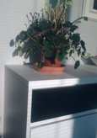 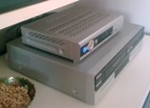 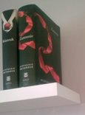 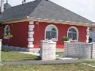 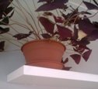 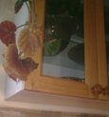 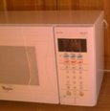**

**1 2 3 4 5 6 7**

**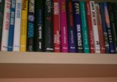 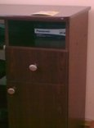 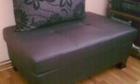 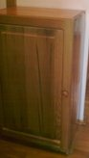 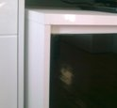 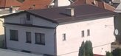**

**8 9 10 11 12 13**

**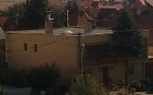 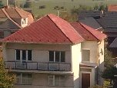 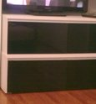 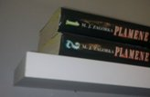  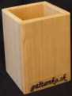**

**14 15 16 17 18 19**

**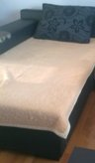 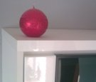 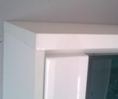 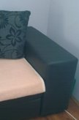 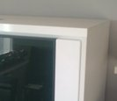 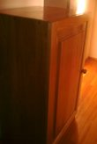 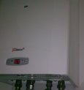**

**20 21 22 23 24 25 26**

**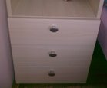 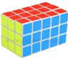 C:\Users\ludmila\Desktop\dataprojektor.jpg  C:\Users\ludmila\Desktop\dom.jpg C:\Users\ludmila\Desktop\kvader_malina_jahoda_ceresna.jpg 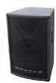**

**27 28 29 30 31 32 33**

1. **Do riadku za sebou vypíš zaradom postupne čísla priradené k jednotlivým obrázkom:**

nadhľady sprava: ---------------------------------------------------------------------------------------------

podhľady zľava: -----------------------------------------------------------------------------------------------

nadhľady: -------------------------------------------------------------------------------------------------------

nadhľady zľava: -----------------------------------------------------------------------------------------------

podhľady: ------------------------------------------------------------------------------------------------------

podhľady sprava: ----------------------------------------------------------------------------------------------

1. **Vypíš všetky typy pohľadov, ktoré vidíš na obrázkoch:**

|  |  |
| --- | --- |
| 1. |  |
| 2. |  |
| 3. |  |
| 4. |  |
| 5. |  |
| 6. |  |

1. Myšlienka na každý deň! Dopíš písmená, ktoré zodpovedajú číslam z kľúča.

|  |  |  |  |  |  |  |  |  |  |  |  |  |  |  |  |  |  |  |  |  |  |  |
| --- | --- | --- | --- | --- | --- | --- | --- | --- | --- | --- | --- | --- | --- | --- | --- | --- | --- | --- | --- | --- | --- | --- |
| **A** | **Á** | **B** | **C** | **Č** | **D** | **Ď** | **E** | **H** | **I** | **Í** | **J** | **K** | **L** | **M** | **N** | **O** | **P** | **R** | **S** | **T** | **Ť** | **U** |
| 1 | 2 | 3 | 4 | 5 | 6 | 7 | 8 | 9 | 10 | 11 | 12 | 13 | 14 | 15 | 16 | 17 | 18 | 19 | 20 | 21 | 22 | 23 |

|  |  |  |  |  |  |  |  |  |  |
| --- | --- | --- | --- | --- | --- | --- | --- | --- | --- |
| **Ú** | **V** | **Y** | **Ý** | **Z** | **Ž** | **:** | **,** | **.** | **Ľ** |
| 24 | 25 | 26 | 27 | 28 | 29 | 30 | 31 | 32 | 33 |

|  |  |  |  |  |  |  |  |  |  |  |  |  |  |  |  |  |  |  |  |  |
| --- | --- | --- | --- | --- | --- | --- | --- | --- | --- | --- | --- | --- | --- | --- | --- | --- | --- | --- | --- | --- |
| **21** | **19** | **10** |  | **25** | **8** | **4** | **10** |  | **16** | **8** | **17** | **6** | **13** | **14** | **2** | **6** | **1** | **12** | **30** |  |
|  |  |  |  |  |  |  |  |  |  |  |  |  |  |  |  |  |  |  |  |  |

|  |  |  |  |  |  |  |  |  |  |  |  |  |  |  |  |  |  |  |  |  |
| --- | --- | --- | --- | --- | --- | --- | --- | --- | --- | --- | --- | --- | --- | --- | --- | --- | --- | --- | --- | --- |
| **20** | **25** | **17** | **12** | **8** |  | **16** | **2** | **14** | **1** | **6** | **26** | **31** |  | **12** | **1** | **28** | **26** | **13** |  | **1** |
|  |  |  |  |  |  |  |  |  |  |  |  |  |  |  |  |  |  |  |  |  |

|  |  |  |  |  |  |  |  |  |  |
| --- | --- | --- | --- | --- | --- | --- | --- | --- | --- |
| **20** | **18** | **19** | **2** | **25** | **1** | **16** | **10** | **8** | **32** |
|  |  |  |  |  |  |  |  |  |  |

**Riešenie:**

TRI VECI OVLÁDAJ: SVOJE NÁLADY, JAZYK A  SPRÁVANIE.

|  |  |  |  |  |  |  |  |  |  |  |  |  |  |  |  |  |  |  |  |  |  |  |  |
| --- | --- | --- | --- | --- | --- | --- | --- | --- | --- | --- | --- | --- | --- | --- | --- | --- | --- | --- | --- | --- | --- | --- | --- |
| **21** | **19** | **10** |  | **25** | **8** | **4** | **10** |  | **23** | **21** | **23** | **29** | **23** | **12** | **30** |  | **17** | **6** | **25** | **1** | **9** | **23** | **31** |
|  |  |  |  |  |  |  |  |  |  |  |  |  |  |  |  |  |  |  |  |  |  |  |  |

|  |  |  |  |  |  |  |  |  |  |  |  |  |  |  |  |  |  |  |  |  |  |
| --- | --- | --- | --- | --- | --- | --- | --- | --- | --- | --- | --- | --- | --- | --- | --- | --- | --- | --- | --- | --- | --- |
|  | **14** | **2** | **20** | **13** | **1** | **25** | **17** | **20** | **22** |  | **1** |  | **25** | **33** | **24** | **6** | **16** | **17** | **20** | **22** | **32** |
|  |  |  |  |  |  |  |  |  |  |  |  |  |  |  |  |  |  |  |  |  |  |

**Riešenie:**

TRI VECI UTUŽUJ: ODVAHU, LÁSKAVOSŤ A VĽÚDNOSŤ.